# **Next Generation AI: An Intro to GPT-3**

### **GPT-3: The next leap in AI**

Selecting transcript lines in this section will navigate to timestamp in the video

- Today, artificial intelligence, or AI, is becoming so ubiquitous it can be found embedded across the enterprise, in our factories, our homes, and beyond. We've come to expect machines and software to recognize our voices and words, identify faces in photos, and so much more. Despite how remarkable AI appears today and all the ways it'll amends and largely improves our lives, it is still in its relative infancy. However, with the emergence of powerful new capabilities led by breakthroughs in algorithm design, the harvesting of massive data sets, and lightening fast processing, a new generation of AI is emerging. To understand where AI is headed and what it may mean to you, your career, and your organization, you must understand the basics of a new chapter in AI, the arrival of GPT3. GPT3 is AI software that can generate texts of such good quality that it is hard to distinguish from something written by a human. But as you'll discover in this course that's just the beginning of its capabilities. Hi, I'm Dr. Jonathan Reichental, business owner, professor, and author. I'm delighted to take you on an educational journey that will expand your notion of what computers are capable of delivering, and the increasing and varied role they may play in the world of tomorrow. Come on, join me on this voyage of discovery. Let's go. (upbeat music)

### **The role of AI in business**

Selecting transcript lines in this section will navigate to timestamp in the video

- For thousands of years humans have been using all manner of complex tools to assist in their daily activities. It's what separates us from most of the rest of the animal kingdom. Augmenting our work has largely been welcomed. Over time our tools have become vastly more elaborate and helpful. (machines running) Without machines, for example, the industrial revolutions would have been impossible and the world we know today would not exist. Directly and indirectly these tools and machines have enabled technology that has elevated billions of humans out of extreme poverty. Some human work has been almost completely replaced by technology such as mass production assembly lines. Many areas of our lives of being greatly enhanced such as the utility of smartphones. Today, with a combination of robotics and artificial intelligence or AI, smart machines are designing, developing and deploying solutions with less and less input from humans. AI-enabled capabilities powered by game-changing software and vast amounts of data are demonstrating familiar human behaviors such as problem solving and object recognition. There are few places where artificial intelligence is more apparent today than in our factories and in our businesses. Enterprise applications are increasingly being powered by smart AI-enabled software. Helping to drive and accelerate innovation as well as optimize aspects of the economy such as the supply chain. We also use this software in areas such as financial forecasting, human resources and in product lifecycle management. New AI capabilities are being introduced all the time. Sometimes there is a sudden leap in innovation. In 2020, one such event happened. GPT-3 was introduced to the world. GPT-3 or Generative Preformed Transformer version three, I know a mouthful, I'll stick with GPT-3 for this course, is the latest version of software created by OpenAI, a San Francisco based research laboratory. It has established a new remarkable bar for AI and is welcoming a new era of computing possibilities. Scientists, philosophers and others have called it one of the most interesting and important AI systems ever produced. By processing vast volumes of data from the internet, GPT-3 can automatically generate writing that reads so naturally it appears as if a person wrote it. It can do a lot more too as you'll discover in this course. So let's look at what GPT-3 is, what it can do, the opportunities and challenges it presents and what it may mean to you, your career and your organization.

### **Brief history and overview of AI today**

Selecting transcript lines in this section will navigate to timestamp in the video

- AI is garnering a lot of attention these days. What exactly is it? And the question that you're likely asking, is it destined to make humans obsolete? But first a definition. I like this one from Merriam-Webster dictionary. AI is the capability of a machine to imitate intelligent human behavior. Most other definitions are a variation of this. The idea that human activities can be simulated by a machine, is at the core of AI research and development. It would be easy to believe based on its recent high profile that AI emerged in just the last few years. In fact, AI has been an area of serious research since the 1950s, meaning we've been working on it for almost 70 years. In recent years, improved computing performance and networks, software languages and operating systems, algorithms, and big data have all contributed to an acceleration in AI research and breakthroughs. Popular culture would have us imagine AI in the form of C-3PO in Star Wars or HAL 9000 in 2001 a Space Odyssey. In reality, AI is software that is embedded in devices from our smartphones, to dishwashers, and self driving cars. Yes, and the occasional human looking robot. While AI at some level can appear magical, today it performs a particular set of tasks well. As a result, the most common functions are appropriately called Narrow AI. This differs from other forms of AI, such as AGI or Artificial General Intelligence which is the notion of reasoning and thinking machines, the distinction will be important later on. Fundamentally AI takes existing data, lots of it the more the better, and use a statistical techniques to help software learn how to become progressively better at a relatively narrow task. This type of approach is called machine learning, or ML. It's great at performing activities such as returning results in online search, image recognition such as identifying an object in a digital photograph, recognizing our voice commands made to Siri and Alexa, and enabling self driving cars to avoid collisions. A subset of ML called Deep learning uses advanced algorithms and lots of data to support the concept of learning by example. Specifically show a Deep learning program many pictures of bicycles, and it will soon know what a bicycle is in almost any picture presented to it. Every outcome with ML can be improved and be more accurate through the use of deep learning. Today, AI research and applications are expanding to include areas such as problem solving, perception, planning, and the control of systems for robots. While many organizations are still building their own AI solutions and many will continue to, access to sophisticated capabilities is being simplified by big vendors providing AI as a service. Players such as Microsoft, IBM, Amazon, Google and others are making it easier for AI functions to be embedded in all types of software solutions. As an example, any organization wanting to include a Chatbot and interface between a human and machine that simulates a basic conversation, can simply copy a few lines of code onto their website and get the power of a massive AI supercomputer at their disposal. AI is enhancing many aspects of the human experience. It's often obvious for example, when we use a map to get directions. They can also be less apparent when AI optimizes for fuel and weather in order to route a commercial aircraft to its destination. Despite how remarkable AI appears today, it's important to recognize that we're in the early stages of its potential. In the years ahead, and as you'll see particularly with the emergence of GPT-3, it's real impact is still to be felt. The biggest challenges of AI in the future may not be the technology, but questions that involve ethics, philosophy, culture, regulation, and economics. Will be able to evaluate some of these questions and the potential business and career opportunities of AI through the lens of understanding where it's headed. That's where we'll go next to the story of open AI and the creation of the next leap in AI GPT-3.

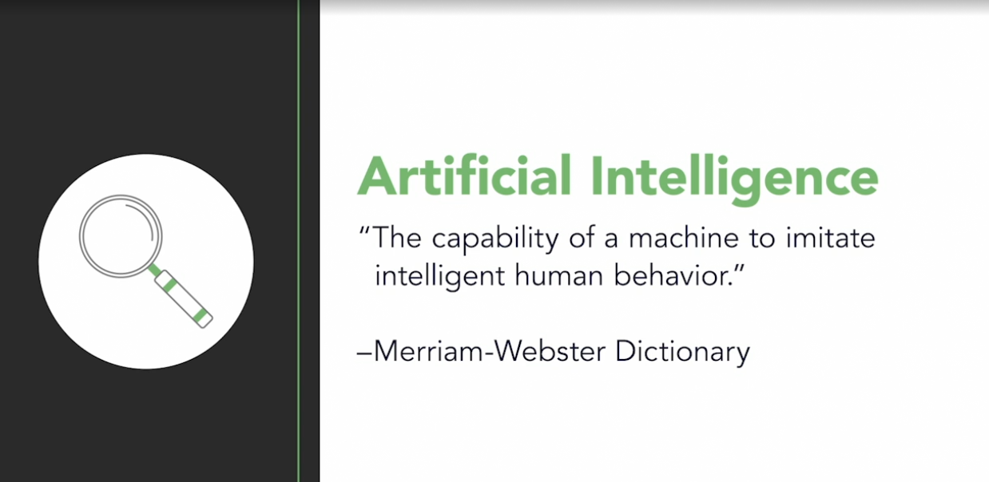

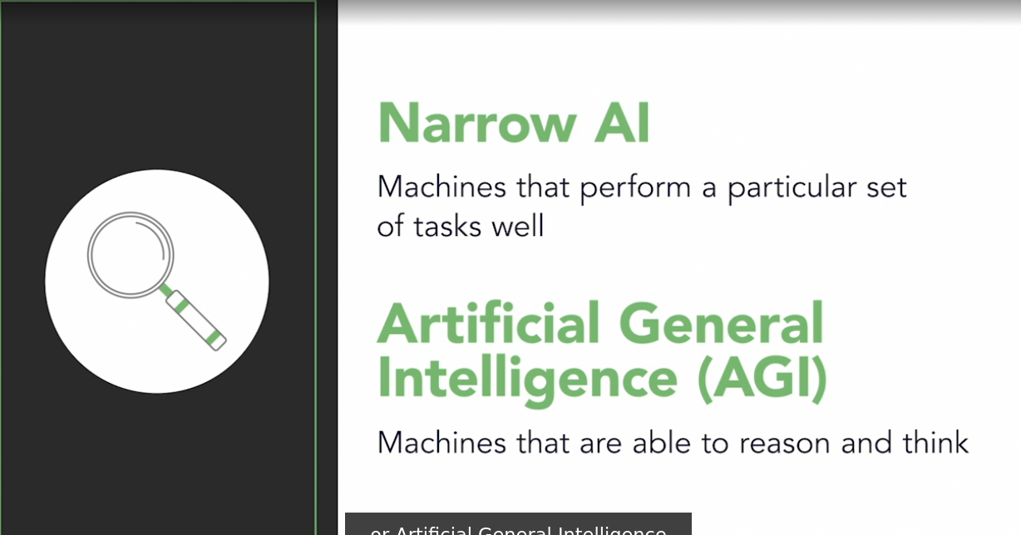

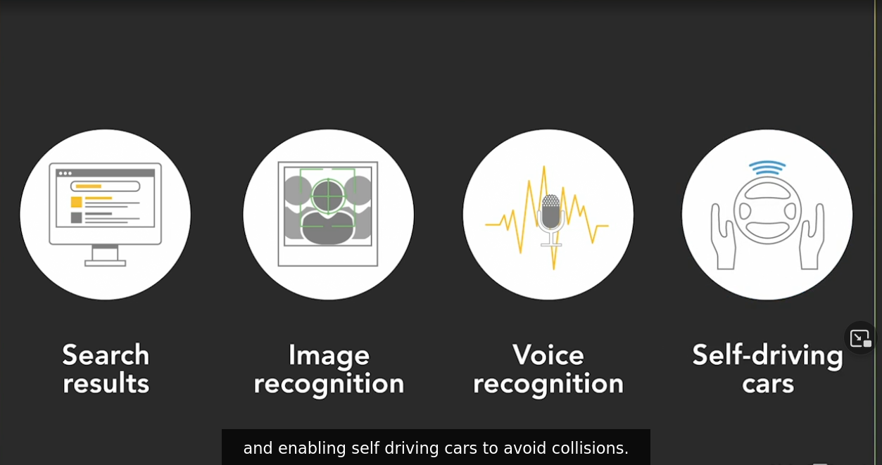

FUture Challenges in AI

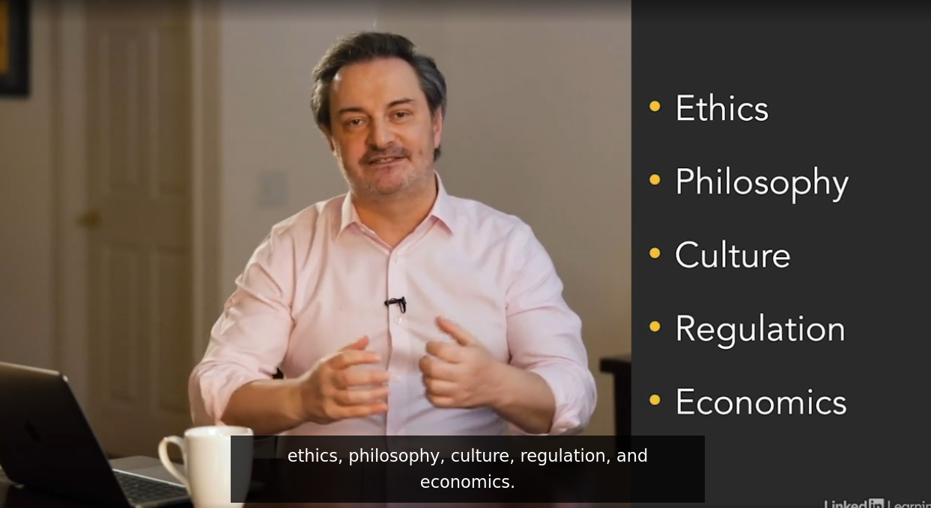

### **Overview of the OpenAI company**

Selecting transcript lines in this section will navigate to timestamp in the video

- To understand what motivated the formation of Open AI, the San Francisco based company behind the GPT-3. I need to briefly discuss a core debate, within the AI community. It's this debate, which makes open AI notable in terms of its Genesis as an AI development organization. This debate asks whether advances in AI present on one side of the argument, a better more prosperous future, or on the other side, a future where AI is to be feared. Those who say AI is a positive force, such as Ray Kurzweil, the American Inventor, Futurist and Machine Learning Director Google, argue that it will free up humans from more leisure time and enable us to focus on creative pursuits. Those on the other, concern side of the argument, such as Bill Gates, the former CEO of Microsoft, worry that AI is both amazing and dangerous. He fears, for example, AI being applied a warfare to manage autonomous weapons, those that search for and destroy targets without human intervention. Elon Musk, the CEO of Tesla and SpaceX, has been outspoken about his concerns. Much like the late Stephen Hawking, the notable theoretical physicist and cosmologist. They both characterize some forms of future AI as potentially humanity's greatest existential threat. A concerning view, indeed. Responding to this concern, in October 2015, Elon Musk, along with Sam Oltman, former president of startup accelerator Y Combinator and other investors such as co-founder of LinkedIn Reid Hoffman and Peter Thiel co-founder of PayPal created open AI. Corporations, such as Microsoft and Infosyst were also founding members. By acknowledging their concerns about the risks of future AI and committing to actions to prevent such risks. These partners formed Open AI to promote and develop friendly AI in a manner that would benefit humanity. To demonstrate their commitment, together the founding team pledged over $1 billion to create the organization. Their mission was clear. Open AI would be focused on ensuring that artificial general intelligence or AGI would benefit the world. They would build safe AGI and we'll consider their mission fulfilled if their work aided others in achieving the same outcome. The organization began as a nonprofit in early 2016 with nine researchers. By April of that year, they released their first product called Open AI Gym. A toolkit for developing and comparing reinforcement learning algorithms. Reinforcement learning is when a computer employees trial and error to come up with a solution to a problem. The AI receives either rewards or penalties for the actions it performs . In December 2016, Open AI released universe. A platform for enabling AI software to interact with a computer such as viewing what's on the screen and using a virtual keyboard and mouse. These solutions were followed by several more in the machine learning space. And in 2018, Open AI published a paper on generative pre-training and what would soon become the first versions of GPT software. I discuss the details of GPT and generative modeling in a later video. Much of the code behind the AI so far produced by open AI, has been open sourced and is freely available. This is to encourage transparency, learning that dissemination of benefits and for the advancement of the code. However, the latest version of GPT version three, the subject of this course has not yet been open sourced. The reasons Open AI provide are mixed, including the size of the code and the opportunity for monetization. They also fear the challenges it could create, given its power to create problematic output that could be offensive or subject users to litigation. More on that later . In 2019 ,Open AI dropped its designation as a pure non-profit and became a for-profit enterprise. This was done to attract further investment by allowing investors to get returns, if open AI became profitable. Microsoft stepped forward and became a significant investor by pumping $1 billion into the new commercial entity. Further, Microsoft became Open AI's preferred partner to license its technology and integrated into their existing as your powered AI platforms. And into their new products and services. Elon Musk's involvement in Open AI decreased significantly in 2018. After resigning his board seat. He cited a potential conflict of interest with his work at Tesla in developing AI for self-driving cars. He does remain engaged as a donor. Today ,with the remarkable initial success of GPT-3. And with the weight of Microsoft behind it. Open AI is well positioned to produce further AI breakthroughs and have a discernible impact on all of our futures.



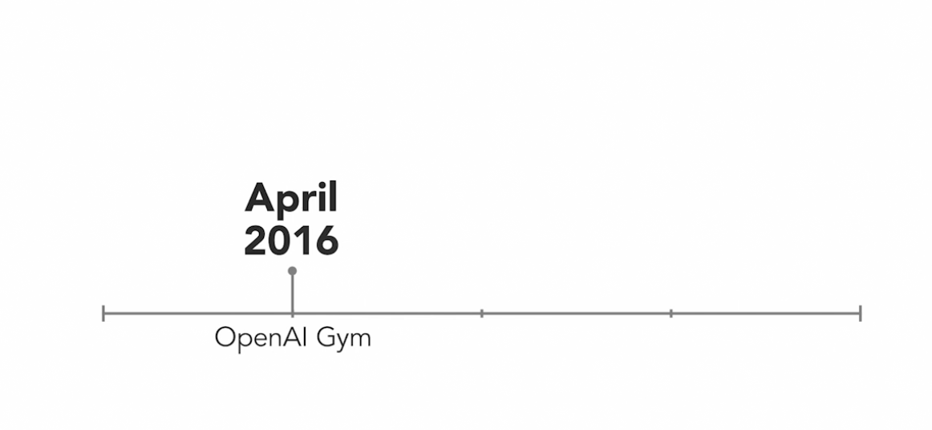

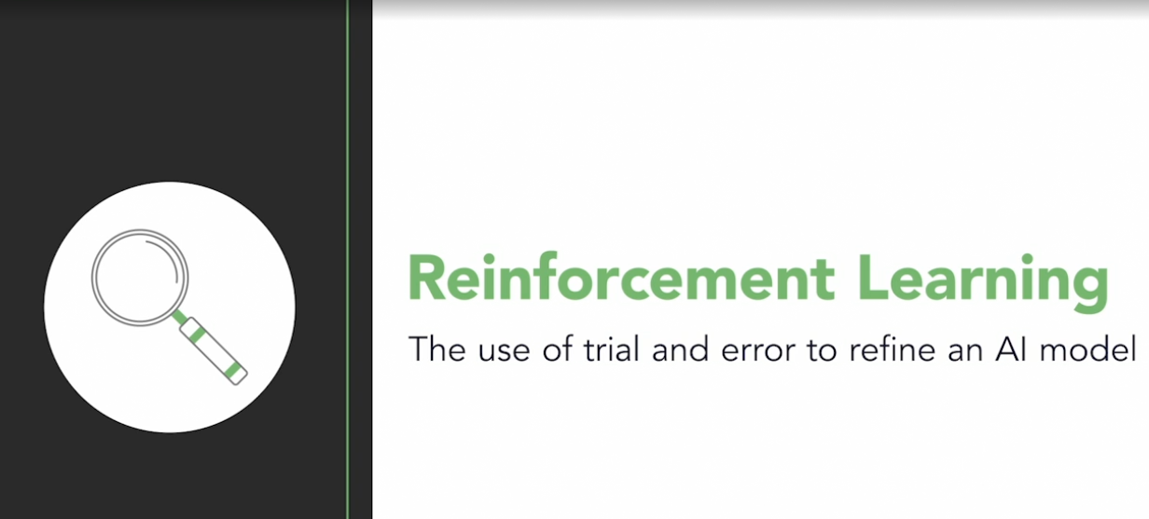

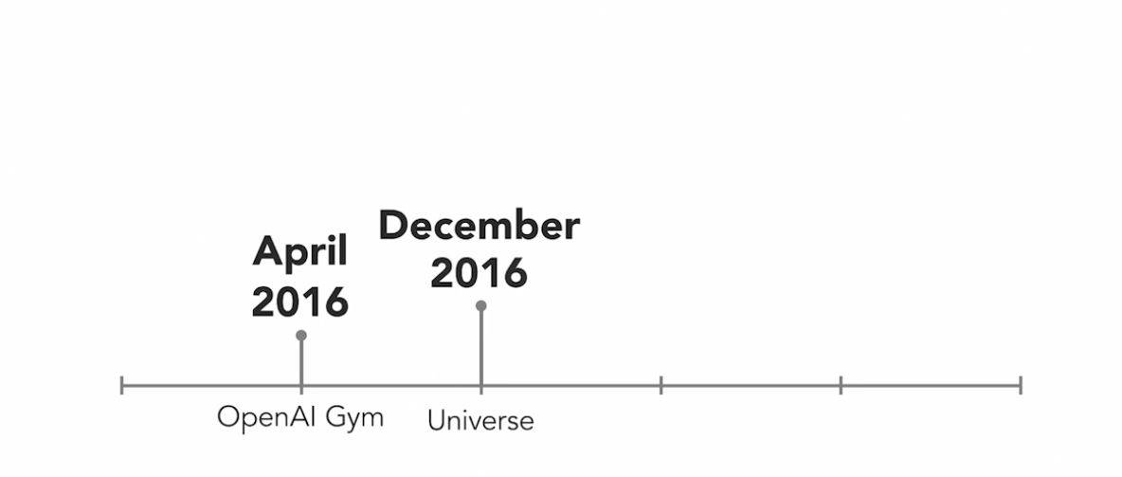

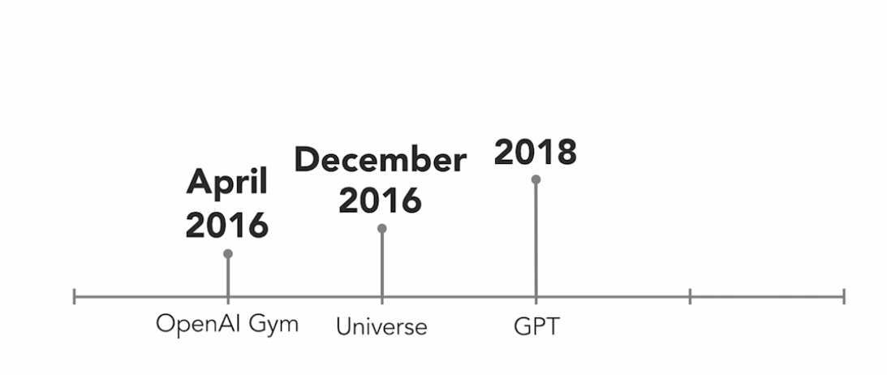

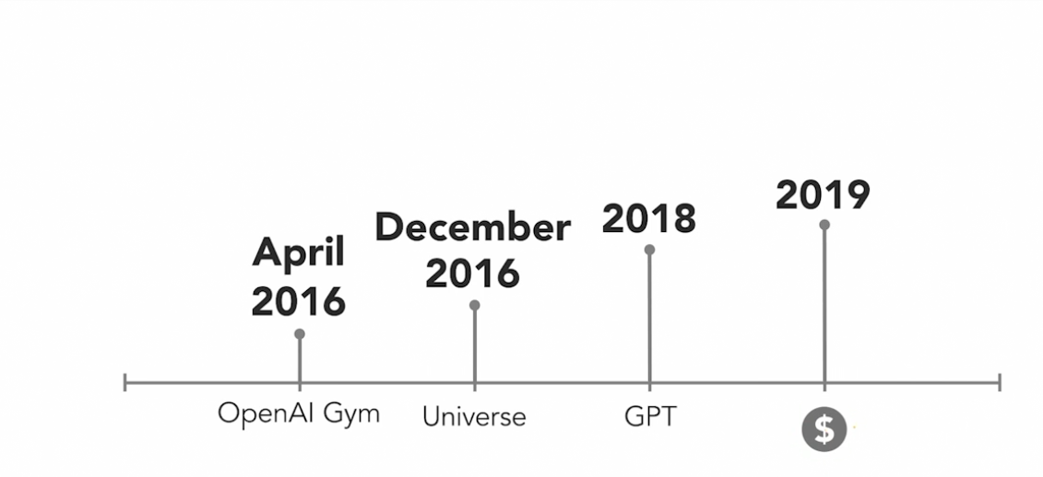

### 

### **The OpenAI charter**

Selecting transcript lines in this section will navigate to timestamp in the video

- The OpenAI organization is distinguished, not just by their track record in releasing groundbreaking AI solutions, but by its mission to support the friendly use of AI technology. With many concerned about the possible nefarious implications of future AI, OpenAI's mission is considered a refreshing and enlightened organizational approach to an important topic and technology domain. The subject of how we approach AI is not novel to OpenAI. Machine ethics, which include the ethics of AI, is a topic dedicated to the subject and includes participants such as universities, philosophers, corporations, and others. Governments are involved, too. The topic of AI regulation and legislation is now part of the discourse. In the United Arab Emirates, for example, there's a Minister of AI whose purview includes the ethics of AI. Machine ethics include complex areas, such as bias in AI, weaponization, morality, robot autonomy, and liability. Each of these are beyond the scope of this course, but dependent on your interest, may warrant further research, including delving into the excellent AI courses in the LinkedIn Learning Library. Now, let's turn our attention to OpenAI and machine ethics. In 2019, in an attempt to capture the principals by which they execute their mission of enabling AI for the benefit of humanity, OpenAI published a charter. The document is a codified expression of their strategy and was developed with feedback from inside and outside the organization. It's an important artifact that goes beyond communicating their values. It can provide inspiration and guidance to others who are looking to adopt similar approaches to AI. While I encourage everyone to read the charter, and I include a link on the screen here for you, here is a brief overview of the main four principles. First, the benefits of artificial general intelligence, or AGI, should be enjoyed by everyone. The focus should remain on the advantages to all of humanity. Second, AGI research and development should be safe. In addition, and particularly notable, if an AGI project emerges from a competitor that could incentivize speed to market at the cost of safety, OpenAI will not compete and will instead partner and assist the competitor. Third, OpenAI will strive to be leaders in both AI and AGI as knowledge of the cutting edge capabilities of the technologies are necessary in order to mitigate the risks and amplify the benefits. Finally, they are committed to broad collaboration with research and policy institutions across the world. Central to this is sharing as much of their research as is reasonable. They want to participate in the building of a strong AGI community across the planet to ensure that AGI challenges are addressed. I'm sure you'll agree that these are admirable and lofty values. However, the degree to which they can be met over the long term are unknown at this time. In my view, there are two key ideas to take away from OpenAI's charter. Number one, we should recognize the novel and unique nature of this organization and its mission. It was born and lives on the foundation that AGI must be created safely and for the good of humanity. And two, these principles can be leveraged to develop an AI or AGI charter for any organization that believes in protecting humanity and amplifying the benefits of this remarkable technology for all. I hope it inspires you and your organization as well.

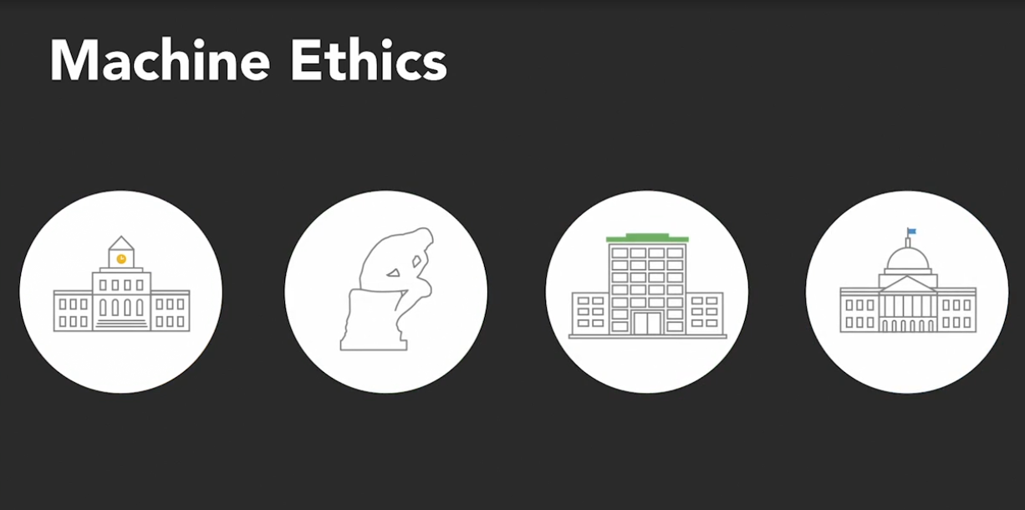

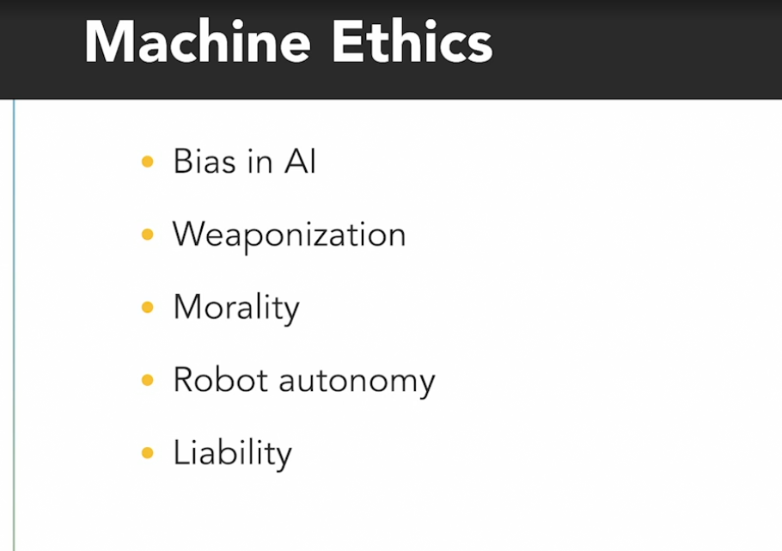

**AI charter**

Benifits for everyone AGI

Safe Search and Development

Leader in AI and AGI

Broad Collaboration

Take away from OPenAI charter

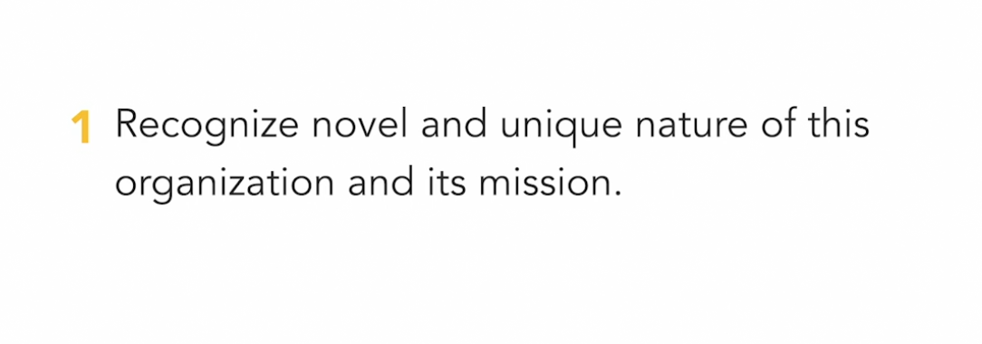

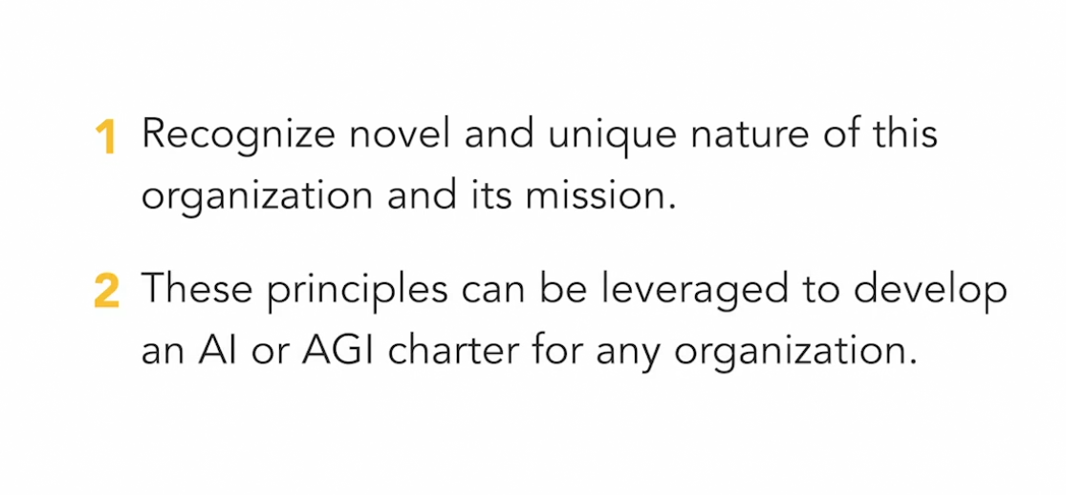

### **Brief background on natural language processing (NLP)**

Selecting transcript lines in this section will navigate to timestamp in the video

- One of the core features of GPT-3 is the ability to ingest large amounts of existing content and use it to create original output that emulates human-based text. The quality of output is so high that it's often difficult to distinguish it from something written by a person. This is not the only feature of GPT-3, as we'll see later, but it is its central feature. To enable and support this high-quality output, a number of AI techniques are employed. In particular. GPT-3 utilizes an approach that is at the intersection of AI, computer science and human language, called natural language processing, or NLP. Understanding the basics of NLP can help you to further contextualize and appreciate the breakthroughs in GPT-3. Let's begin with an example of NLP in action. Many of us now issue voice commands to digital devices, such as the popular virtual assistants Amazon Alexa and Google Home. We also ask our smartphones and laptops through voice with all manner of requests. These devices listen to our words and try to make sense of them, derive meaning, process the input, and then execute some action such as providing directions or playing your favorite album. This is done through NLP. This same technology that makes sense of voice commands can also be applied to text inputs on a computer. This enables function such as chatbots, search engines, language translation, spellcheck, and sentiment analysis, a process that classifies emotion in subjective language. This is NLP hard at work in the background. It's complex, state-of-the-art software. At a high level, NLP generally works like this. The software needs to pre-process the text in sentences in order to provide some form of structure that can be used as the basis for interpretation. One or more of the following can be used. One, the sentence is broken into each word. This is called tokenization. The individual words are known as tokens. Unnecessary punctuation is removed. Two, words can be identified and tagged as nouns, verbs, adjectives, pronouns, et cetera. And third, the application of stemming. This is where words are standardized and put in context by reducing them to their root form. For example, the words banks, banker, and banking are all associated with the root word bank. This is the stem. That root word will also be used to assign the context for all the others to a financial institution and not the act of turning an aircraft. Once the text has been pre-processed, a machine learning or ML algorithm is used to interpret the data. These algorithms use statistical models based on vast volumes of example data called training data to suggest what action to perform. When the pre-processed text is analyzed by the ML algorithm, it is looking for words, phrases, and patterns of text that are familiar from the training data. If there is a high probability that the words and context are understood, the NLP now knows the topic of the text. Finally, NLP can be used for natural language generation or NLG. This process analyzes and pre-processes text, interprets it and then uses insights from the input to generate new content. We'll see this capability applied in GPT-3.

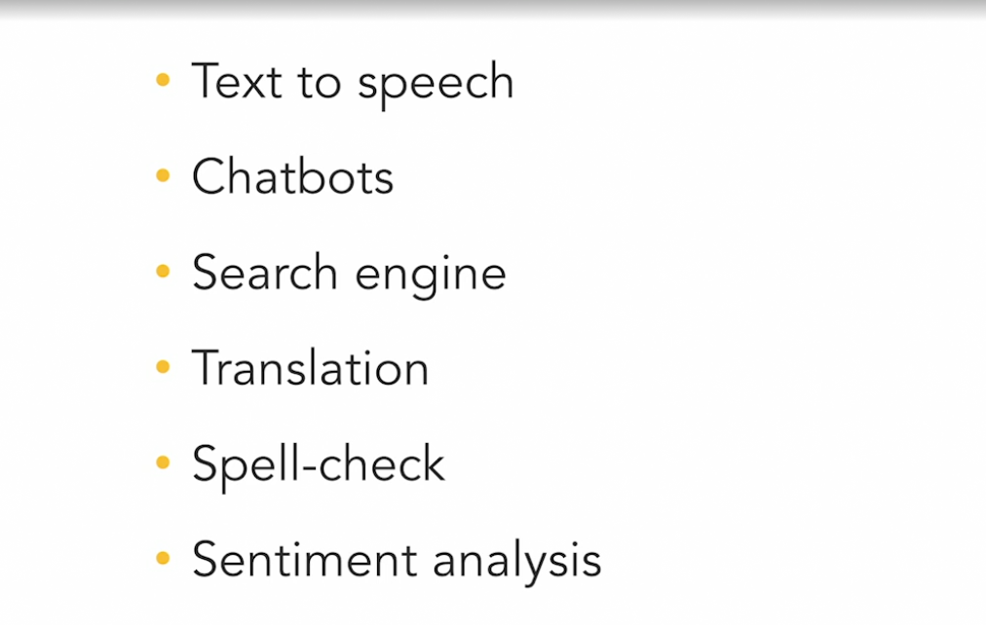

**How it works**

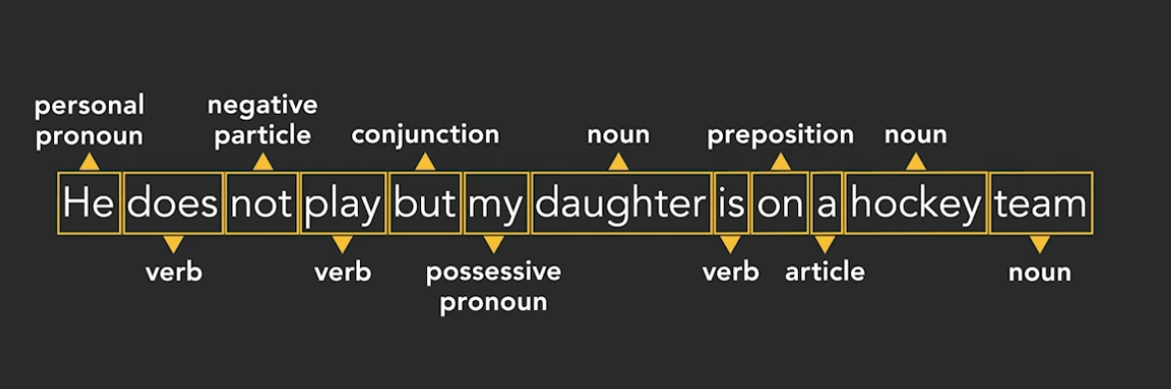

NLG : Natural Language Generation

### **What is GPT-3?**

Selecting transcript lines in this section will navigate to timestamp in the video

- GPT-3 stands for Generative Pre-trained Transformer version three. A name like that was obviously created by people that know nothing about marketing. It's certainly a mouthful. Joking aside, GPT-3 uses advanced algorithms, a set of rules for problem-solving that computers follow, and lots of data to create original human like text and other output. Sophisticated Natural language processing, NLP, produces natural language generation, NLG. The quality of output that GPT-3 produces is so good, it is hard, even impossible some would say, to discern it from human generated text. GPT-3 can create meaningful stories, poems, emails, chat bot responses, even software code with just a few prompts from a human. For example, take a look at how GPT-3 based in some training data was able to change legal jargon into plain English. I'm sure you'll agree that this is helpful. I know I struggle often with reading legal contracts. Later on, I will provide many compelling examples. GPT-3 is based on a generative model of language. Generative models use existing knowledge of language to make predictions on what words may come next based on a series of previous words. This is where we get the word generative in Generative Pre-trained Transformer, or GPT. As a simple example, if you type once upon a, the model will predict time as the next word based on its analysis of a large corpus of content. Knowledge in this case, or what we call Training Data, for the system is acquired from a variety of sources, including Wikipedia and Common Crawl, a free set of data with about a trillion words, derived from perusing the internet. To help make the system smart so to speak, text is randomly removed from the acquired content and the software is trained to fill it in with the correct missing words. This is where we get the word pre-trained in Generative Pre-trained Transformer. Powering all of this is a type of AI called Deep Learning, which is based on 70 years of research in neural networks. These networks power the AI learning process by consuming training data. For example, for an AI powered recognition system to learn what a bicycle is and identified in a picture, it must analyze large volumes of existing bicycle pictures. It's cold a neural network because it loosely mimics the function of the brain. The network consists of a web of connected nodes or computational units. The type of neural network used in GPT-3 is called a Transformer. It's particularly good at taking text and reusing it in another context or word sequence, while maintaining meaning. This is where we get the word transformer in Generative Pre-trained Transformer. In a neural network, data moves through nodes based on certain criteria. One of these criteria is weight or strength of connections between nodes, a concept I'll return to shortly. If criteria are not met, data does not get processed. If it does, it moves to another node. This repeats until the data rise transformed at the end of the neural network. What makes GPT-3 a game changer relative to its two prior versions, is a number of model parameters. GPT-2 had 1.5 billion. GPT-3 has 175 billion. It is currently 10 times the size of the next largest model, the Turing NLG developed by Microsoft. In other words, it's really, really big. But what are these parameters? A model parameter is a variable whose value can be estimated from data. The data I'm referring to here is the training data that is fed to GPT-3. In the process of learning from the data, the algorithm stores values in the model. Each parameter assists with increasing the probability of a text prediction being accurate or relevant. Intuitively, the more parameters that exist, the higher the likelihood of quality predictions. In GPT-3, the sentence beginning once upon a, has a close to guaranteed probability of the correct completion. Next, I want to talk briefly about few-shot learning. A test of AI capability is the degree to which humans must provide it with answers in advance, to get a correct outcome. It is generally acknowledged that the fewer examples AI needs in order to predict accurately, the better the quality of the AI solution. For example, let's say we want to use AI for translation from English to French. We enter the word cheese and wait for the AI to translate. Since the algorithm doesn't know what language to translate it to, it's not going to be able to do anything. This is called zero-shot learning. In other words, we provided no guidance. However, if we instead feed the AI with friends equals ami, then query what cheese equals, now it has something to work with. This is one-shot learning. GPT-3 looks for a pattern using its vast language model. It may get the right answer. Finally, if we give GPT-3 more examples, now we're into few-shot learning. House equals maison, friend equals ami, rain equals pluie, then query what cheese equals, the likelihood of GPT-3 getting the right answer increases greatly. Of course fromage, pretty cool, right? Depending on what GPT-3 is being tasked with, it has been shown to provide good results in each of zero one and few-shot learning. Now, finally, unlike its predecessors, GPT-3 is not being made freely available. While the public API will be available to use under certain conditions, in late 2020 Microsoft assumed control of the source code. It will be fascinating to see how Microsoft incorporates GPT-3 capabilities into its products such as Word, Excel, and Bing. And how it provides it as a service on its Azure platform. GPT-3 is certainly not without some significant weaknesses and challenges. I'll explore those later. As is the case with all innovation and scientific breakthroughs, Microsoft and others will build on the new groundbreaking baseline of GPT-3 in order to create even more powerful AI in the years ahead.

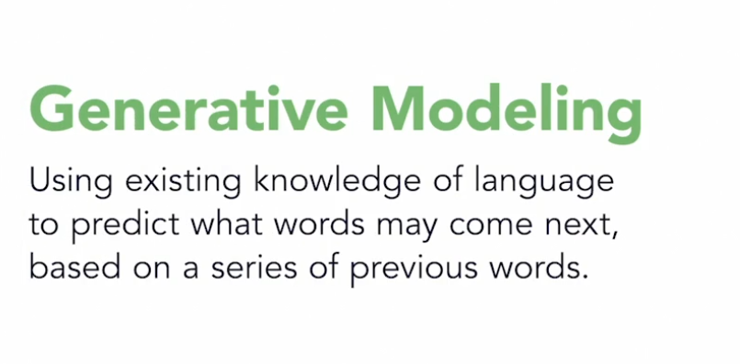

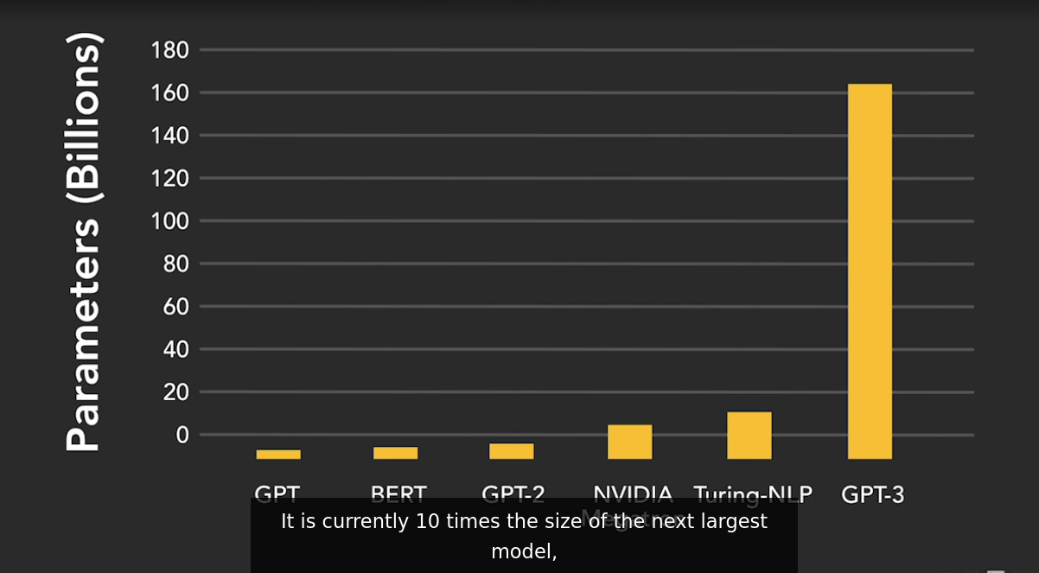

**Few shot learning**

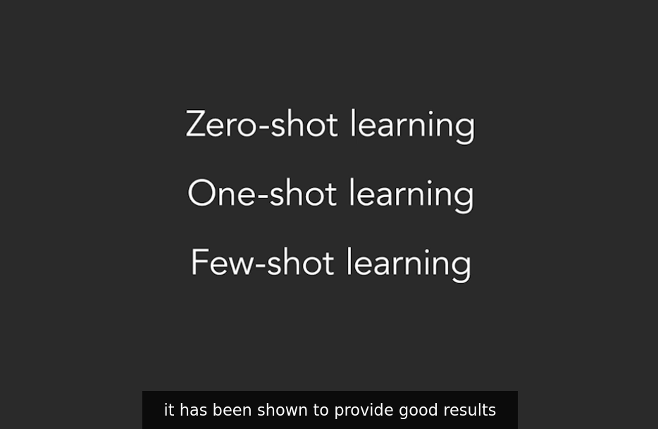

### **Uses and examples of GPT-3**

Selecting transcript lines in this section will navigate to timestamp in the video

- GPT-3 was released for use in experimentation to a limited audience in 2020. So far we've seen a lot of remarkable demonstrations and even a few full solutions. The degree to which GPT-3 will be incorporated fully into production solutions, particularly by Microsoft who now have substantive rights over it are yet to be seen. However, many early demonstrations of the technology are a wonderful tease of its possibilities. Let's take a look at a few. I'll start with GPT-3 running as a function within Google Sheets. In this example, some cells include the data for the populations of four US states. Michigan is then added without knowledge of its population. The GPT-3 function is then entered in the cell where the population result will reside. The parameters for the function are the existing states and populations in the spreadsheet. GPT-3 processes the information and determines from the pattern that the missing information is the population of Michigan, which it then goes ahead and populates. We can see by changing state name and even adding additional state information, that GPT-3 is smart enough to pool in the missing information. You'll recall that this is known as Few-Shot Learning. In the next more advanced example GPT-3 is going to process some text and create computer code based on what has been written. In other words, what you see here is someone simply typing in a description and you can see that GPT-3 is generating the appropriate code on the left and you can see the output of the code on the right. This example is so remarkable, could it make programming software as easy as describing what you want without any knowledge of computer code at all? It's a tantalizing prospect (laughs). Next, let's take a look at how GPT-3 answers some questions. While GPT-3 hasn't passed the Turing test yet, the gold standard for AI where a human can tell whether it is another human answering a question or software, but it comes close. Under rigorous testing, it becomes clear that GPT-3 does make too many basic mistakes. Here you see a set of questions about animals, it answers them correctly. In the last question, it is asked whether any animals have three legs. The answer is no, but the follow-up is interesting. It's asked why no animals have three legs. And the answer given is that the animal would fall over. Let's be clear, GPT-3 didn't logically deduce that last answer, but the ability to find exactly the right answer from its database is an admirable accomplishment for software. This next example is particularly impressive for me as a professor and instructor. One of the things I often have to do is create quizzes for my courses. In this GPT-3 demo, all that is needed are the questions, a student then enters answers and GPT-3 checks them. It processes all the input and determines what answers are correct and incorrect. This is really powerful because the students is free to express the answer in their words. The software does not impose any constraints on how to answer. GPT-3 can handle the unstructured nature of the responses. In this next example, we can generate human faces of people who don't already exist, simply by typing in a description. Watch us some basic details are entered, then generate is clicked. GPT-3 takes a moment to process the request and create photo realistic faces. We do it for a woman and then a man, the results are quite remarkable. If this particular example intrigues you, I recommend taking a look at a website called "This Person Does Not Exist", here's the URL. It's not built with GPT-3, but it's another form of AI based on machine learning and neural networks. Lots of other fascinating demos exist that help create legal language for contracts from plain English or vice versa. It takes legal language and converts it to something we can all understand. Others show how entering a math problem in plain English can be converted to an equation and then it'll solve that equation. What GPT-3 does best is generating text. There are numerous examples of GPT-3 generating complete emails from just a few text prompts. Poems have been written, essays have been composed, science papers and news articles have been generated. Sure there are plenty of errors and clues that the content is not human, but the effort is pretty good. Try some GPT-3 applications yourself. Here's a resume builder. I include more in the final video in this course. Finally, while I focused on GPT-3's incredible ability to generate meaningful texts in these examples, let's look at a unique implementation of the technology called Dali. The name comes from a portmanteau of the artist Salvador Dali and Pixar's WALL-E. Instead of generating text, Dali takes text and generates images, a pixel at a time. For example, in a popular demonstration of its capabilities, the sentence, "an armchair in the shape of an avocado", generated a collection of convincing images of chairs in the shape of an avocado. Let's recognize the breakthrough here. These images aren't pre-existing and stored in the database, these are original images generated on the fly. For example, a snail made of a harp generates several images that are clearly unique. Since GPT-3 hasn't been trained specifically to create snails made of harps, it's achieving this outcome through zero-shot learning. I could imagine all manner of designers, for example, loving Dali. However, my guess is that this capability will be far reaching as it develops. You can experiment with Dali on the OpenAI website. GPT-3 hints at the future of AI in general. If you're feeling almost a little uncomfortable, that's understandable. Today, AI augments human activities increasingly well, but how long will it be until it overtakes us? And what might that mean for our future?

DallE text to picture

### **Challenges and limitations of GPT-3**

Selecting transcript lines in this section will navigate to timestamp in the video

- GPT-3 has been received with some fanfare. Rightly so. It's a stunning achievement of contemporary computer science. But despite its impressive ability to generate text, code and other results in a manner that has the appearance of human work, it has some significant challenges and limitations. We also need to remember it's still in the test stage. Even Sam Altman, the CEO of Open AI, has admitted that the hype may be too much. While recognizing that AI will change the world, he considers GPT-3 just an early glimpse of what may be ahead. The big issues with GPT-3 can be categorized into two large areas. One, it has technical imperfections and two, it risks replicating human bias. Both of these categories are rooted in the understanding that GPT-3 doesn't think in the sense that humans think, it uses clever algorithms and data to give the illusion of thought. In this way it is still closer to narrow AI than artificial general intelligence. Let's look at both of these challenging areas. I'll begin with the technical limitations. While producing human-like short text output is generally remarkable, when asked to produce large amounts of text with some complexity, the quality of the output declines. It can sometimes read like gibberish. GPT-3's impressive understanding of language comes from the volume of training data that it accesses. Common Crawl, one of the main sources of data, contains billions of phrases and a trillion words from across the internet. Here's an example of how using this training data in the absence of actual intelligence can result in an erroneous result. The following paragraph was entered into GPT-3 and the final words were omitted so that the software could complete it. You are a defense lawyer and you have to go to court today. Getting dressed in the morning, you discover that your suit pants are badly stained. However, your bathing suit is clean and very stylish. In fact, it's expensive French couture. It was a birthday present from Isabel. You decide that you should wear... Now GPT-3 was instructed to complete the paragraph. It added, the bathing suit to court. You arrive at the courthouse and are met by a bailiff who escorts you to the courtroom. GPT-3 processed the text and determined that you should wear the bathing suit to court. Somehow I don't think that this was a wise decision. What we're seeing here is that the GPT-3 algorithm and data knows that a clean bathing suit is something that is wearable, particularly if another item of clothing such as pants are not. What it doesn't have is the intelligence to know that it's a bad idea to wear a bathing suit to court as a lawyer. (chuckling) Next, let's look at the risk of bias in generated output. GPT-3 uses a process of unsupervised learning when it processes its training data. Unsupervised means that the information being ingested is not flagged as being right or wrong. The algorithm learns by looking for and determining patterns. Supervised learning is the opposite and is aided by guidance on meaning and accuracy. There are numerous reasons to choose one approach over the other, but primary to unsupervised training is the ability to process vast amounts of disparate unstructured data quickly without human intervention. While there is a large upside to unsupervised learning the downside is the potential for bias. Central to how GPT-3 works is the ability to look for sequences of words and also words and phrases that are adjacent in related text. This can be problematic. The web contains the entirety of human perspectives. This includes controversial views as well as information that is just plain incorrect. GPT-3 software isn't in a position yet to discern what is right or wrong both from a factual and values-based perspective. Unfortunately, it's therefore always possible that text may be churned out, that is, let's just say kindly, insensitive at best. Let's remember, the web is a reflection of all that is human. Consider this for a moment. If organizations use GPT-3 to auto-generate emails, articles, and papers, et cetera, and there is no human review process, the legal and reputational risk could be significant. Imagine just one article among 1000 that had an ugly racial bias. The consequences could be severe. In a final example, imagine GPT-3 is tasked with grading students' essays. Writing styles and word choices can vary enormously between cultures and genders. Without guardrails, a GPT-3 powered paper grader may grade higher for some students than others based on cultural bias. It's possible that some students would be graded more favorably because their style of writing is more represented in the training data. This can never be acceptable. The makers of GPT-3 understand all these limitations. In fact, in the paperwork accompanying the software, these risks are outlined. The software doesn't yet have the ability to eliminate these risks and simply it issues a buyer beware warning. Using new technology is by default a risky endeavor. But the examples in this video should make it clear that with AI, the risks of this technology can have significantly higher consequences. As we progress forward with this technology and incorporate it into our lives and organizations, we must never forget this.

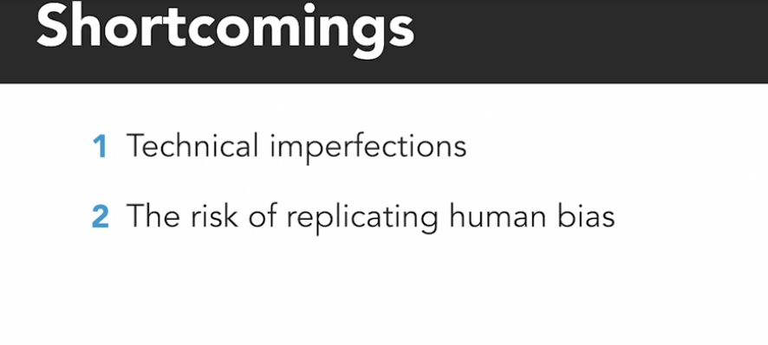

### **The future of GPT-3 and AI**

Selecting transcript lines in this section will navigate to timestamp in the video

- While GPT-3 today is remarkable and valuable on many levels, in my view, one of its most important qualities is how it may inform us about what is ahead for AI. Let's first look at what GPT-3 may mean to customer service. Many of us have likely already experienced the increasing use and value of chat bots. A chat bot is online software that enables a human to converse with a computer. Typically, we see it in customer service. You might visit a website, and a chat bot will pop up asking how it may help you. To date, these have supported relatively simple exchanges. Asking for product prices and availability or phone numbers is common. The chat bot does a simple search and returns the answer. However, complicated exchanges have been elusive so far. Entering a complex question usually results in a standard answer, suggesting it doesn't understand the request, or it just refers the users to a human customer support. GPT-3 is changing this. First, it provides the possibility of a much better customer experience by broadening the ability for replies with details and accurate answers. However, as more questions are answered and more insights are derived from customers who ask the questions, the chat bot becomes smarter through transfer learning. This is a machine learning method that uses previous insights as starting points for new requests. It's like when a human learns to paint with watercolors. When they later use oil paint, they don't have to relearn how to hold the paintbrush. As AI develops, the chat bot conversations will seem more human, because the further the conversation progresses, the richer the dialog. Unlike early versions of AI, where each question and answer exists ephemerally, the software will retain and build an attained knowledge. Next, let's briefly look at what GPT-3 and its future may mean to our work. It's reasonable to acknowledge that skills and experiences limit many people from participating in certain work. That's why we go to school and pay for expensive education. For example, it's not possible to simply sit down in front of a computer without specific skills and write a complex software program. However, what happens when AI acts as a mediator that converts plain English into code that normally requires deep skills? We get something called low coding, or with GPT-3 and its successors, no coding. Suddenly, high demand highly-skilled work has been devalued, and simultaneously the opportunities for innovation explode. It's a double-edged sword. Other work that will likely be automated by GPT-3 and future AI ranges from the explanation of legal documents, translation services, medical answers, solving math problems, content development, such as news articles and blog posts, and even website creation. Sure, today we're still a little distanced from any significant job impact from GPT-3. But can it be too long as new versions and improvements emerge? The leaps in performance demonstrated by GPT-3 establish a new research baseline. We can assume that whatever comes next will be more powerful. Many have pointed out clear GPT-3 limitations and errors, but as it matures, we can expect these to fade away. AI today still can't pass the turing test that's still the respected bar for determining where developments stand. It's only a matter of time before AI aces this test. Then we'll see AI augmenting and replacing any number of interactions that would typically be staffed by a human. Why not? It can work 24/7 without pay, never get tired, and it can almost infinitely scale. Finally, GPT-3 considerably raises the bar on our expectations of AI. But let's not get ahead of ourselves. GPT-3 doesn't get as much closer to sentience, emotions, human-like reasoning, and consciousness. That said, humanity appears determined to reach those goals.

### **Skills required for AI in business**

Selecting transcript lines in this section will navigate to timestamp in the video

- What's becoming clear now is that with each day that passes more and more organizations are adopting artificial intelligence, they're incorporating it into their products and they're using it to run better operations, even if it's not deliberate yet, most organizations are already using AI in some form because it's in the applications they use on their devices or it's integrated into industrial machines. Soon it's believed AI will be as ubiquitous as connectivity and electricity with AI taking a larger role in organizations, it will be advantageous to take strategic, tactical and operational approaches to this technology. GPT-3 as an example, demonstrates both the rapid progression of AI value and it opens the possibilities for innovation, it's now time for most organizations to step up to this opportunity. Let's take a look at some of the skills that businesses may want to identify and acquire as a plan and develop for an AI future. At the leadership and management level, it's important to have a vision for AI in the organization, that's going to require education on what's possible, GPT-3 provides strong clues on where the technology is headed in the next few years. Leaders must also attain a good understanding of AI providers, the solutions they are providing, and the roadmaps they are following. Management must also be prepared to take some additional investment risks and be open to experimenting, grooming a culture of innovation becomes even more important. Recent research in "Harvard Business Review" claims that early adopters of innovation using digital technologies are growing twice as fast as many of those who are technologically conservative. For many organizations short to medium-term plans for AI are going to be primarily focused on acquiring existing tools with integrated AI, for example, data analytics, geospatial information systems, financial modeling, and others that are off-the-shelf will generally ship with AI baked in. Many XaaS service or Everything-as-a-Service solutions cloud delivered applications from vendors such as Oracle, Salesforce, SAP and others will include AI-enhanced capability. Some simple examples include optimization techniques and spreadsheets or managing design suggestions in a presentation application. Training will be more important than ever, knowing how to tap into these new functions and leverage their value can enhance employee performance. For a growing number of businesses, there will be enthusiasm to build their own AI-powered solutions, it's a more complex route, but with plenty of upside including attaining competitive advantage, through providing superior products and services. If you're one of these organizations, you will want to explore some of the following roles, intuitively you're going to need some AI engineers that are skilled in writing algorithms for machine and deep learning, tightly related to these roles will be the need for data scientists and data integration engineers. Overall, AI must be fed the right data in the right manner to enable it to function well, with a heavy emphasis on software development, your AI needs will require software engineers that can program in popular AI supporting languages such as Python, C++, and Java. API or application programming interface development in particular will be a value since AI often requires passing data among disparate systems or calling on the functions of other software, GPT-3, as an example is an API-based service. Finally, to compliment the technology team, organizations should consider talent in user experience design, business analysis and agile project management, these are the skills that can assure a contemporary approach to software design and development. Preparing your organization for the challenges and opportunities of the 21st century means being in a forward leaning position, it will require bolder choices, greater risks, uncertain investments, and a culture of innovation, and the bottom line, it'll be all for nothing, if you don't have the right skills available.

### **Career and business opportunities in AI**

Selecting transcript lines in this section will navigate to timestamp in the video

- One of the challenges facing any of us who write, teach, or work in the enterprise AI field is that the definition is somewhat fluid. For example, should we consider software that alerts us when a server's running low on storage space to be AI? There's no simple answer to how we should define it short of software that simulates human intelligence. We must acknowledge that the opportunities for AI in the enterprise could be narrow or exceptionally wide based on interpretation. For our purposes here, let's assume a broad definition. With this in mind, the opportunities to drive AI business value are considered to be substantial, particularly for large enterprises. Gartner, a leading analyst firm, projects that the dollar amount could reach almost $4 trillion in 2022. We all know it's only going to go up from there for the foreseeable future. Gartner's research indicates this value will be derived through improved customer experiences, new revenue opportunities, and cost reductions. Today and for some time to come, AI implemented in a novel fashion in products and services offers unique, competitive advantages. Pursuing improved customer experiences, new revenue opportunities, and cost reductions are being driven rapidly by an increasingly hypercompetitive marketplace. Organizations have recognized the role of technology, and particularly digitalization, as a core mechanism for achieving these strategic objectives. This means we need greater collaboration between the business and IT departments. There's room for improvement there, as many organizations still think digital transformation is a role for IT rather than an all-hands-on-deck approach. With pressure in the marketplace and more options for technology empowerment, the organizational focus is shifting to an innovation mindset. In support of this, businesses are leaning towards X as a service, or everything as a service, essentially cloud-based architecture. This provides greater business flexibility, the freedom to pursue innovation instead of what are becoming commodity technology services, and greater emphasis on managing data. Handling big data is particularly important with regard to AI projects. In recent research conducted by CompTIA, one of the world's leading technology associations, the top five potential uses for AI in business outside of identifying new revenue opportunities were the following. Improving workflows, analyzing large data sets, improving customer experience, security monitoring and detection, and finally, handling routine tasks. In their initial AI efforts, businesses are expecting to see cost savings as a primary benefit. This is followed by the ability to handle repetitive tasks better, personalize services, and the discovery of new insights in data. According to CompTIA, the career opportunities for IT professionals and enterprise AI projects are varied. The top five skills include support and troubleshooting of AI issues, AI algorithm development, software development, cybersecurity, and data analysis. As all types of businesses embrace AI technology to improve customer experiences, seek new revenue opportunities, and identify cost reductions, opportunities will abound for ambitious IT professionals looking for specialized tech careers and for those willing to diversify their skillset. In a growing macro environment of work disruption and future career uncertainty, at least in the short to medium term, the development of AI will generate both economic activities and career opportunities.

### **What you can learn about AI next**

Selecting transcript lines in this section will navigate to timestamp in the video

- Artificial intelligence. The ability for software machines to simulate human intelligence is poised to change the world in profound ways in the decades ahead. It's already useful for making recommendations, producing quality search results, getting directions, identifying insights and data, and avoiding bad weather for aircraft. However, leaps in innovation around algorithm design, big data use and computer processing are ushering a new wave AI capability. Specifically the emergence of GPT-3 in 2020 has shown us what is now possible, and it's only a tease of what is ahead. Today, more than ever, successful organizations and careers must recognize the opportunities and challenges ahead and embrace them. In a world of disruption and uncertainty, having a plan is essential. with AI generating increasing amounts of economic value, if this is an area of interest and there is the potential for organizational alignment, this is a great time to take action. If you know my work, you'll know that I always recommend education and research as the first steps. You and your organization need to understand the possibilities. Watching this course was a great start, but it's only a start. Take a look at the many other AI courses on LinkedIn learning. Several go deep into specific AI development skills. You might enjoy dabbling a little in Tensorflow or Python. Both relatively gentle entry points to deeper hands-on AI skills. In addition, check out some of my other related courses such as Everything as a Service is the Future of Business. A topic I mentioned several times in this course. I also recommend taking my Foundations of the Fourth Industrial Revolution course. This is a comprehensive journey through the technologies and trends that will shape the world over the next few years. Specific to GPT-3, there are plenty of online resources to learn more. Particularly a deeper understanding of how it works and how it may be leveraged by you and your organization. If you want to play with GPT-3's capabilities right now, check out any of the following. copy.ai, other side ai.com and play.aidungeon.io Now, as we come to the end of this introductory course, let me ask you a question. Is it possible that some part of this video course was written by GPT-3? More importantly, would it make a difference if you knew? with that, I wish you continued success with your goals. Thank you for watching and good luck.